**Project Development Phase**

**Model Performance Test**

|  |  |
| --- | --- |
| Date | 10 November 2022 |
| Team ID | PNT2022TMID35588 |
| Project Name | **A Novel Method for Handwritten Digit Recognition System** |
| Maximum Marks | 10 Marks |

**Model Performance Testing:**

Project team shall fill the following information in model performance testing template.

|  |  |  |  |
| --- | --- | --- | --- |
| **S.No.** | **Parameter** | **Values** | **Screenshot** |
|  | Model Summary | **-** |  |
|  | Accuracy | Training Accuracy – 99.57%  Validation Accuracy -99.01% |  |

1.Model Summary

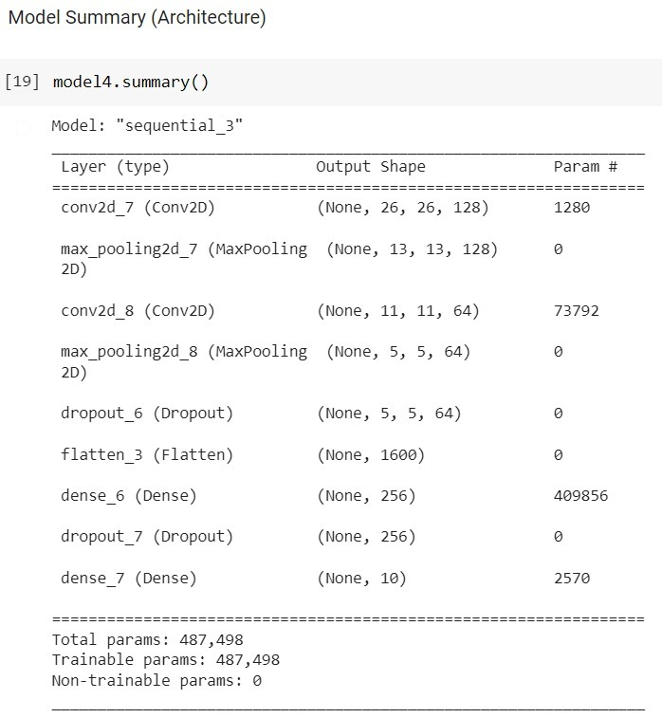

2.Accuracy

